

[stores sales prediction



**Content**

Abstract ------------------------------------------------------ 2

1. Introduction --------------------------------------------- 3

1.1 Project Overview -----------------------------------3

1.2 Objective -------------------------------------------- 3

2 .Technical Design Diagram ------------------------- 3-5

3 .Technical Specification ------------------------------- 5

3.1 Servers------------------------------------------ 6

3.1.1 Application Server ------------------------ 6

3.1.2 File Server ---------------------------------- 6

3.2 Access Requirements -------------------------- 7

3.3 Databases --------------------------------------- 7

3.4 Storage needs Exclusive of Databases --------- 7

4 .Sources Required --------------------------------------- 8

5. Conclusion -------------------------------------------------9

Document Tracking --------------------------------------- 9

**Abstract**

To the upcoming Supermarket and the Item Outlets which are going to implement their business for outlet location depends on the tier’s place and the size of the outlets and the establishment year for them ,which the sales will depend on the attributes of the outlet’s.

The sale’s of the Store/s for the particular items for their net quantity and the MRP of the items, Weather will it be of any food type. The amount of sales for the item will show the sales is going good or bad .

In today’s generation everyone need’s an analysis and prediction for the Store’s Sale’s to know the detailed information for their store and income. where the Sales will be depend on the ,how the customers are buying it. Thus it’s necessary for the store to predict the sales of their product.

1 Introduction

1.1 Project Overview

The aim of our project is to predict the Item Outlet Sales of different outlets for different items with respect to the item attributes

**1.2 Objective**

Predict the sales for the different outlets for the items sales ,which have the different attributes like item type , item fat content , item weight, item visibility and the item identifier which will depend on the outlet ty[e , outlet identifier ,and also the year of establishment of the year ,which shows the stores sales , so we have to predict the Item Outlet Sales with respect to the given data.

**1.3 Scope :**

The Sales stores prediction is used for the process of ana-

-lysing the sales of their product’s, which is used for their future improvement based on the customers purchases .thus they required the machine learning algorithms to predict the sales by processing step by step evaluation. Overall the should be given before the requirements and then define during data design work analysis.

2. Technical Design Diagram

* I used scikit learn for import the models and the algorithms.
* Python for running the code .
* Jupyter notebook for running the python code.
* I used Matplotlib ,seaborn and plotly for data visualization.
* Kaggle is used for downloading the Dataset from their website.
* I used machine learning algorithms for executing the models.
* GitHub is used for uploading the project ,in public.

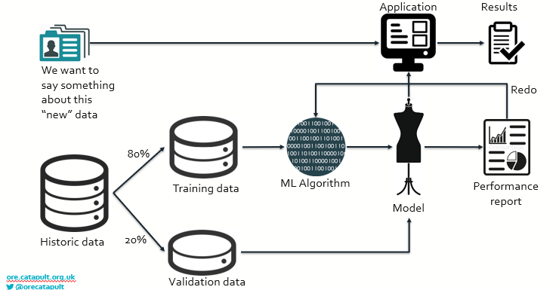



[This Photo](https://commons.wikimedia.org/wiki/File:Jupyter_logo.svg) by Unknown Author is licensed under [CC BY-SA](https://creativecommons.org/licenses/by-sa/3.0/)

* 3. Technical Specifications
* Windows 7/ 8/10
* RAM 8Gb (min)
* Anaconda Navigator
* Jupyter Notebook
* 3.1 Servers
* Jupyter Notebook
* Operating System : Windows 10
* Application memory requirements : Ram 8 GB
* Application CPU requirements :

|  |  |
| --- | --- |
| **Hardware** | **Recommendations** |
|  |  |
| Processors | AMD Ryzen 5 |
| Processor Speed | 3.6 GHz |
| RAM Size | 8 GB |
|  |  |

* 3.1.1 Application Servers

#### JupyterLab is a web-based interactive development environment for Jupyter notebooks, code, and data. JupyterLab is flexible: configure and arrange the user interface to support a wide range of workflows in data science, scientific computing, and machine learning. JupyterLab is extensible and modular: write plugins that add new components and integrate with existing ones.

* 3.1.2 File Servers
* GitLab started saving everything on local disk. While directory location changed from previous versions, they are still not 100% standardized . We can upload the File’s in their Server.

**3.2 Access Requirements**

* For accessing the project u need to have account in GitHub to access it anytime.
* Any user can have Access to the project code which is available

In GitHub account ,which is public ,to access it anytime.

* User communities who will need access, including
  + ITMS Developers
  + Sales
  + Vendors
  + Other

* 3.3 Databases
* SQL Server
* SQL Server version 15.0
* Memory requirements: 1GB
* CPU requirements:

**Minimum:** x64 Processor: 1.4 GHz  
  
**Recommended:** 2.0 GHz or faster

**3.4 Storage Needs exclusive of databases**

* The amount of Storage :

MySQL-800MB (Min)

* 4. Resource Needs
* People (Work Resources)
* Capital (Cost Resources)
* Material Goods (Material Resources)

**5.Conclusion**

The conclusion of the project is the Items of the stores for different outlet’s. Have the different no of sales for the different item’s. And everyone should know their sales ,which will help them for profits and thus our machine learnings models have predicted the best score and the analysis for the store .

* Document Tracking
* The following chart is used to log of all changes made to this document.

| **Version** | **Date of edit/change** | **Who made the edit/change** | **Description of edit/change** |
| --- | --- | --- | --- |
| 1.1 | 27-10-2021 | Joshua | Stores sales predict |
|  |  |  |  |
|  |  |  |  |
|  |  |  |  |
|  |  |  |  |

**References :**

Kaggle for Dataset : <https://www.kaggle.com/brijbhushannanda1979/bigmart-sales-data>

Google for images : <https://www.google.com/search?q=machine+learning+cycle&rlz=1C1CHBD_enIN870IN870&sxsrf=AOaemvIZRo1Zhq_Ecn_7o_Bc7JXNjoYgmw:1635366469020&source=lnms&tbm=isch&sa=X&ved=2ahUKEwiA-dnrtuvzAhVj5nMBHbeSBJMQ_AUoAXoECAIQAw&biw=1536&bih=760&dpr=1.25#imgrc=LbWpWk21O-fzvM>